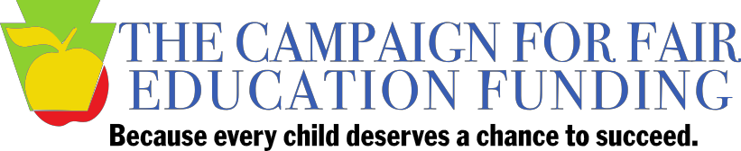

FOR IMMEDIATE RELEASE
CONTACT: Charlie Lyons, clyons@shelly-lyons.com or (717) 724-1681
Carolyn Myers, cmyers@shelly-lyons.com

Campaign for Fair Education Funding advocates for state Senate budget framework
Alternative budget proposal offered by House Republicans comes up short $200 million for public schools

HARRISBURG (December 8, 2015) – The Campaign for Fair Education Funding is urging lawmakers to end the budget impasse by adopting the budget framework passed by the Senate yesterday, which would increase basic education funding by $350 million.
During a press conference today, the Campaign asked lawmakers to reject the alternative budget proposal offered by House Republicans because it does not live up to the agreed-upon framework for basic education and comes up short $200 million for public schools.
"We are here today to urge enactment of a long overdue state budget that puts Pennsylvania on a better path to fund our public schools," said Joan L. Benso, President and CEO, Pennsylvania Partnerships for Children. "The Campaign members joining me today know the importance of getting this done and not letting the budget framework agreed to by the Governor and three of the four legislative caucuses fall apart at this urgent hour."
"Many of our principals across the Commonwealth are reporting that the budget impasse has had a very negative impact on our students," said Dr. Joe Clapper, Assistant Executive Director for the PA Principals Association. "The lack of funding has caused schools to reduce materials, supplies and eliminate educational experiences both inside and outside of the classroom. And, in particular, the schools with the most disadvantaged children have been hit the hardest."
"Students should never be put in the middle of political fighting no matter how noble each side feels their cause is," said Kathy Swope, President-Elect, Pennsylvania School Boards Association. "The reality is that the financial consequences go beyond the mere fact that state money is being held up. In order to keep doors open and pay staff, many districts have had to take out loans to the tune of nearly $400 million—and that number continues to grow."
"There are children all across our Commonwealth being undereducated, and they are suffering because of it," said Dr. Joan Duvall-Flynn, President, Pennsylvania Conference of NAACP Branches. "The people with the power and authority to address it must do so. These children should not be marginalized out of their future."
"While the agreed-upon deal is still moving forward, it appears that the $350 million increase for basic education funding is in jeopardy as a result of a competing budget proposal," said Jeffrey Mummert, Business Administrator/Board Secretary, South Western School District. "Instead of driving us to a final budget, this competing proposal has created more uncertainty and confusion, making our jobs as school business officials significantly harder and putting the landmark $350 million investment in our students at risk."
With insufficient and inequitable funding in recent years, many school districts have been forced to endure cuts in staffing and programs.
Since the 2010-11 school year, half of school districts have furloughed teachers or other staff, 74 percent have cut or reduced at least one academic program and 57 percent have increased class sizes.
The nonpartisan Campaign for Fair Education Funding is a coalition of more than 50 member organizations representing educators, labor, business leaders, faith-based organizations, child advocates, charter schools, traditional public schools, with representatives from rural, urban and growing school districts. The groups joined together last year to urge the state to adopt and adequately fund a new fair education funding formula.
Learn more at www.fairfundingpa.org.
# # #

